ECOR 1042

**Project Report**

**Interactive Book Dataset Reader**

Submitted by

**TEAM T-40**

YUSUF IBRAHIM, 101231208

BRADLEY TAYLOR, 101228342

SOPHIA VERMA, 101224612

JASMINE WONG, 101240501

April 12, 2022

**Carleton University,**

**Faculty of Engineering and Design**

1 **Contents .**

2 The Problem Statement:.........................................................................................................................**2**

3 The Project Goal………………………………………………………………………………………**3**

4 The Project Design: . **3**

5 The Project Process . **3**

6 Team Contributions . **4**

7 References . **4**

# **2 The Problem Statement: .**

There exist millions of books in the world. Each book has various characteristics that, when combined, distinguish them from other books. Trying to find, sort, or organize a large number of books by these specific characteristics would take too long to do manually; finding all mystery books within a list containing hundreds of titles would be tedious. Finding all titles of one category would be tedious but it is not the only way to get books: you might want to get them by author, by rating, or by publisher. There are other ways of reading lists of books as well; sorting the list by specific characteristic or altering the books within the list are possible interactions with a data set. All of these processes would take a significant amount of time to do by hand.

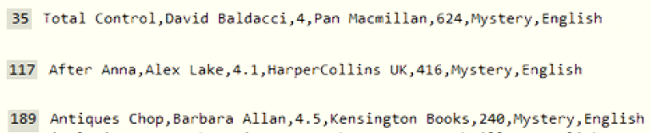

*Figure 1 Three books with the category “mystery” from the data set “google_books_dataset.csv” a great distance apart from each other [1]*

# **3 The Project Goal .**

The project goal was to develop a text-based interactive user-interface that could be used to analyze and alter a data set of books using a set of commands. The user-interface would be able to alter, sort, and retrieve information by certain characteristics from the data set.

# **4 The Project Design: .**

Our program is made up of 4 functional modules that contain multiple functions to create a seamless interaction with a given. The modules are as following:

1) A module containing a function that will take a given data set and turn it into a dictionary. The dataset taken is a csv file with a header containing several book characteristics. Each line following contains information of a single book organized in the same order as described in the header. The dictionary returned removes any duplicate book entries with the same category.

2) A module containing several functions with different capabilities. All of the functions take a dictionary returned from the function found in the first and previous module. These functions include two functions that add or remove a book from the imputed dictionary, a function that gets every category listed for a book in the imputed dictionary, and five functions which get books of a certain title, rating, author, publisher, and category from the imputed dictionary.

3) A module containing four functions intended to sort various books by title, by rate, by publisher, and by author. All four functions will sort a list returned by another function within the same module. This means a total of five functions are found in this module. This additional function will take a dictionary from the function from the first module and convert it into a list containing dictionaries. Each dictionary within the returned list will contain information for one book.

4) A user interface that prompts a user for commands. Each command relates to the various functions found in the previously developed modules. The user interface will continuously prompt the user until the command ‘quit’ is imputed by the user.

# **5 The Project Process .**

The project was developed in modules. Each module consisted of either four or eight tasks. The group contained four people, and the tasks were evenly distributed amongst them. In the first module, each member created a function to store a dictionary from a dataset in four different formats. The next module, there were eight functions. One team member focused on adding and removing a book from the dictionary, and the other team members focused on the six other functions intended to get a book from a dictionary. In module three, each team member made one function each to sort the dictionaries in four different ways. And in the final module, the user interface, there were commands instead of functions. Each team member dealt with a different number of commands that were equally distributed by difficulty.

For the testing, in the first module every team member tested their own functions, and after that each team member tested the functions of the team member under them in the group task delegation.

# **6 Team Contributions .**

J. Wong Problem Statement, Project Goal

Y. Ibrahim Project Design, Project Process

Only two team members worked on the report on it as the other members focused on other tasks. Every team member still had access to the report for review.

# **7 References .**

[1] Brightspace. (2022, March 4). *google_books_dataset* [Online]. Available <https://brightspace.carleton.ca/d2l/le/content/124606/viewContent/2561463/View>